# Basic Game Design Log

**Raw Idea**: Mind Visualizing Game (Educate Simple Programming)

* Plan, Design, Execute Motions

**One Line Description**: Complete Obstacle Challenge with your mind.

**Genre**: Memory, Physics, Puzzle, Platformer, Serious Game

**General Idea of Game**:

1. Plan & Place Helpers
2. Reach Checkpoints
3. Record Movements
4. Execute & Impress the audience

**Target Audience**: Students (Ages 17 – 25)

**Location**: Lab Room Stage

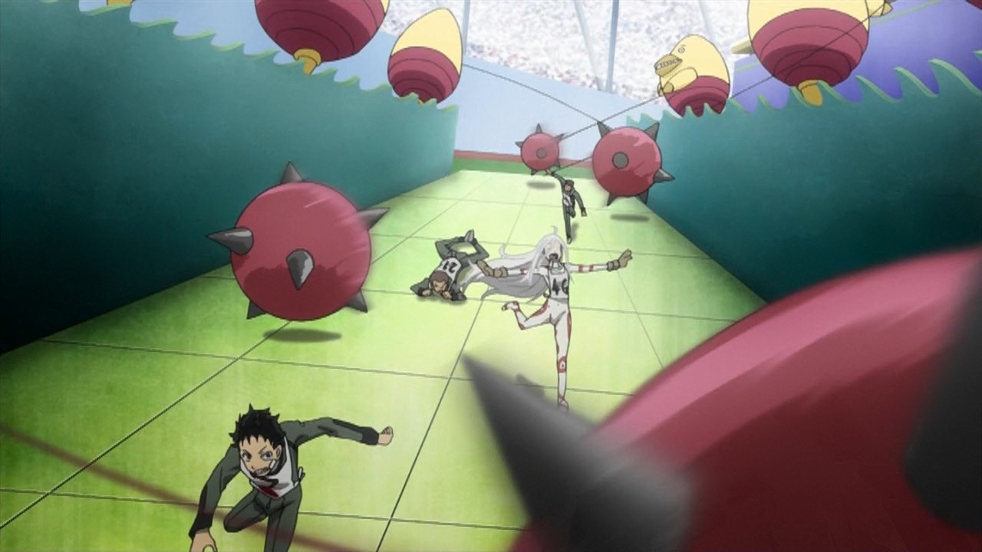

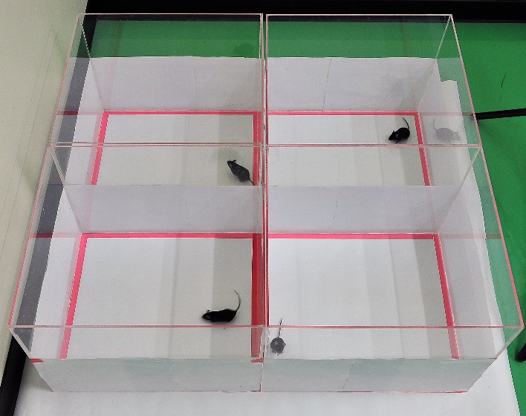**Level Atmosphere**:

* Rich People watching robots at work
* In an isolated, artificial environment (Deadman Wonderland)
* Hazards obstructing robot from reaching destination

**Sounds**:

* Boo Sound Made by Audience
* Movement sound made by robot
* Tension background instrumental

**Pixel Artwork Style**:

* Assets
  + Ceilings Lights
  + Floor Mines
  + Pit Falls
  + Ramps
  + Boats
* Textures
  + Lava
  + Water
  + Metallic Flooring

**Timeline**: First Deadline: 30th October

**Iteration Core Gameplay**: Place 🡪 Record 🡪 Execute

# Base Game Mechanics

**Objective**: Record Set of Movements to get across a map

**Game Rules**: Complete/ Reach Checkpoint within Available Move-Sets while Avoiding Obstacles.

**Minimum Viable Product**:

* Record Movements
* Store Movements
* Place Objects
* Execute Flow

**Basic** **Limiters**:

* 3 Hazards
* 2 Helpers
* 1 Character Controller